**HTML MAILER**

Below screenshots depicts tests results on different email clients namely:

* Outlook installed on a windows 10 system
* IBM Notes
* Gmail
* Mobile device version.

In order to run my test I used an online html email service tester called litmus link <https://putsmail.com/tests/new>

Litmus puts mail allows one to past the html email template and send it to a email client for presentation and all my tests results were produced from there.

The working code for these template can be found here [html mailer](https://github.com/saksman3/Mercedes-Benz-test),

**Tests Results on Gmail** – from a Computer

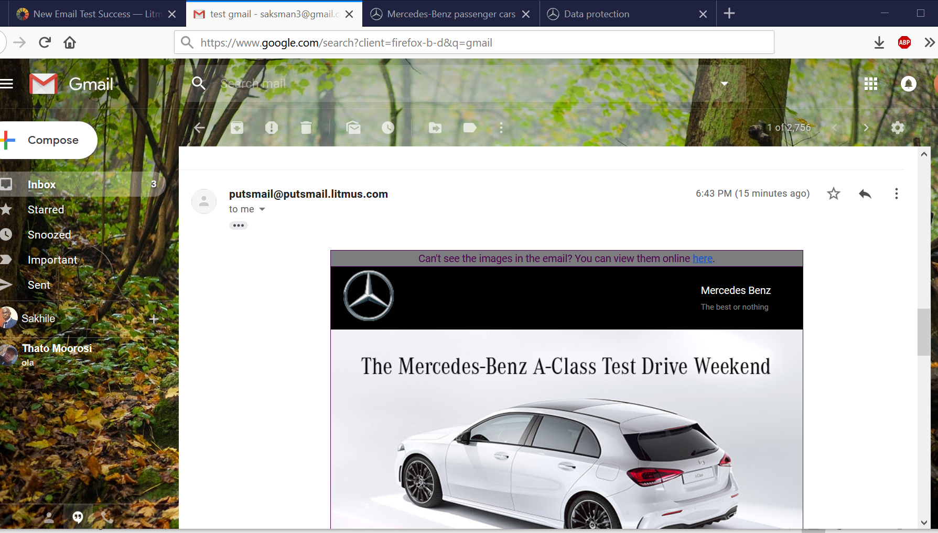

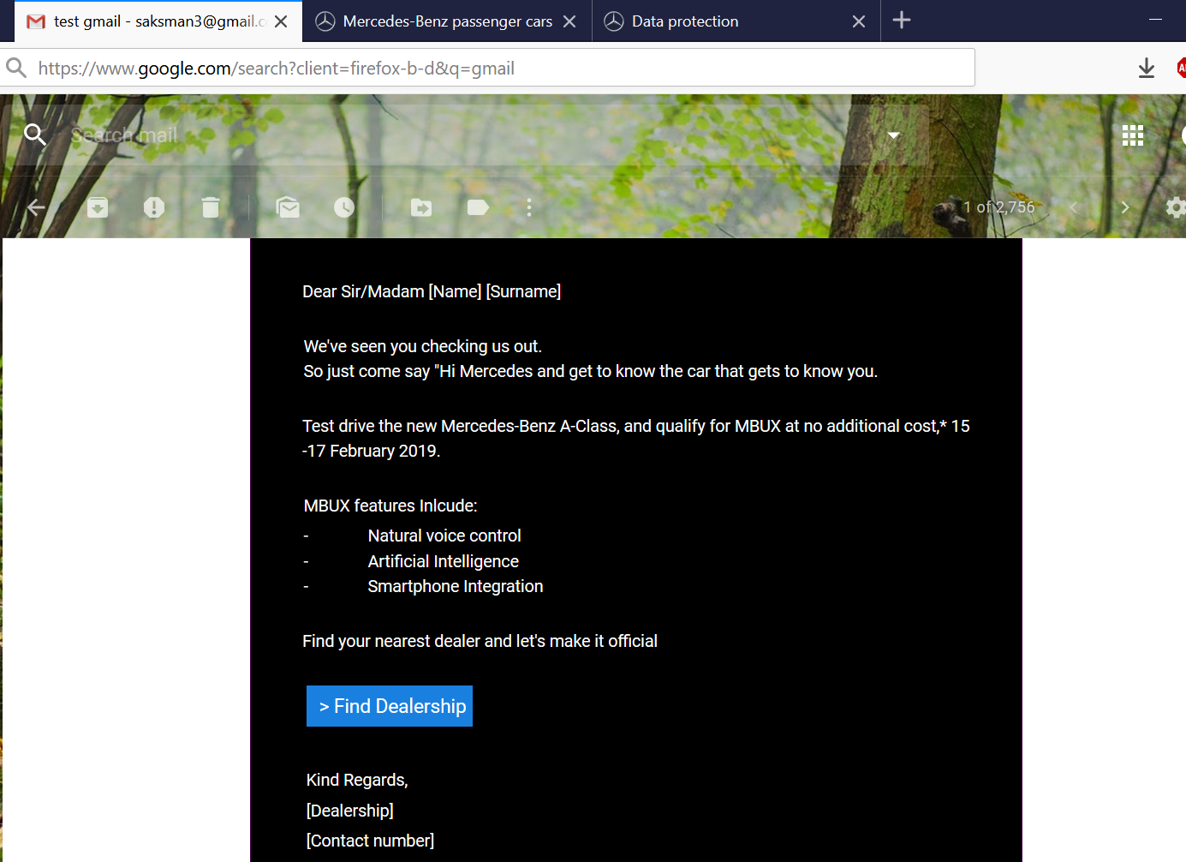

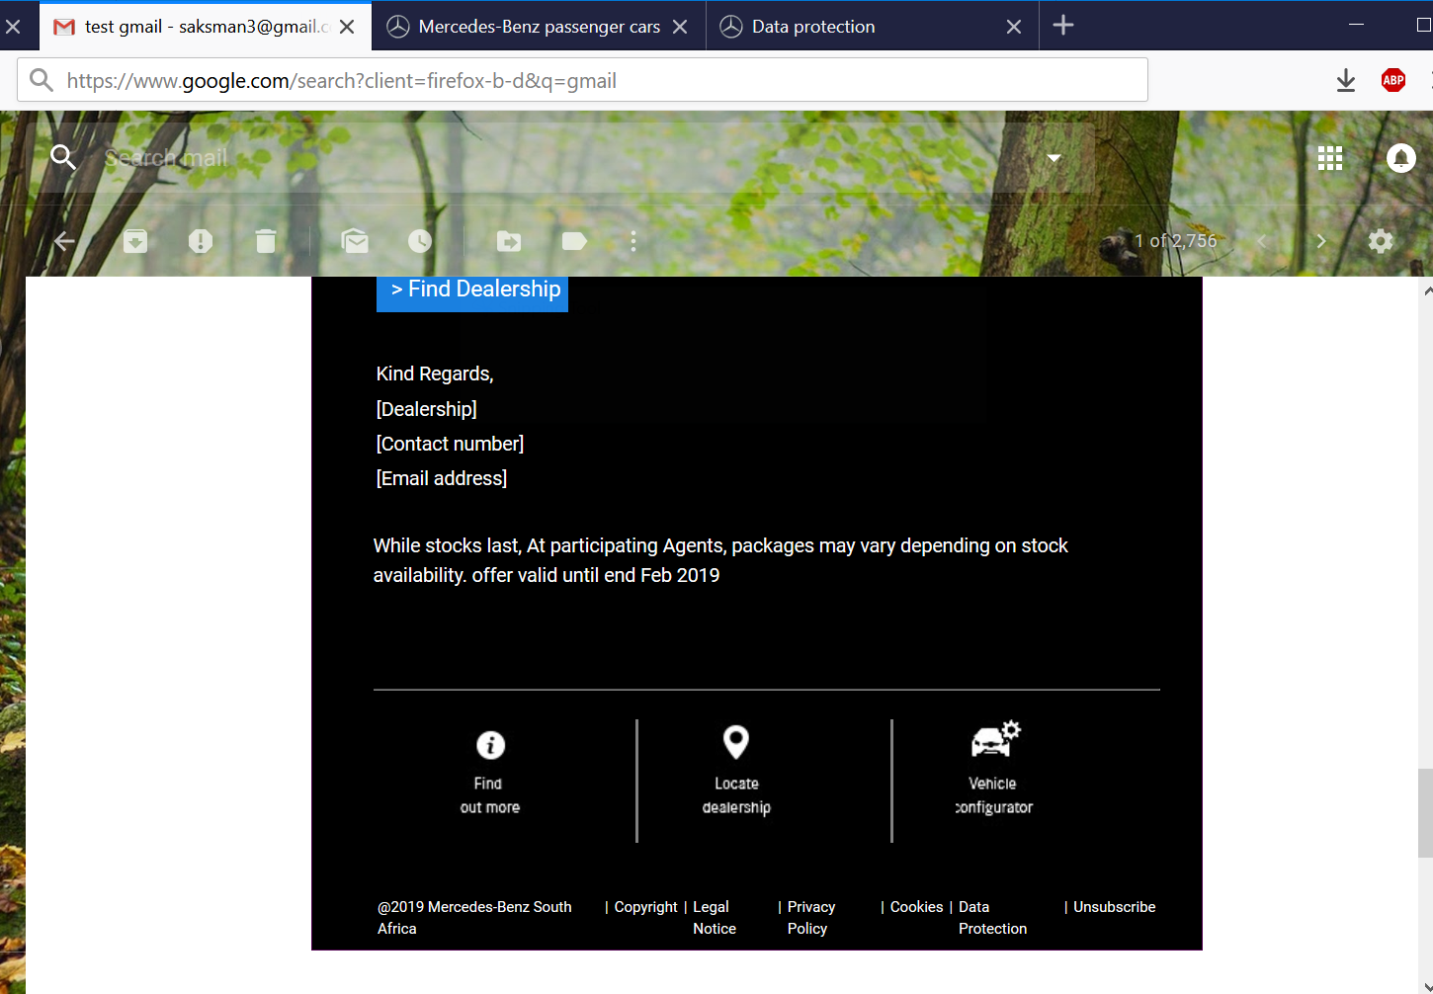

**Test Results on IBM Notes**

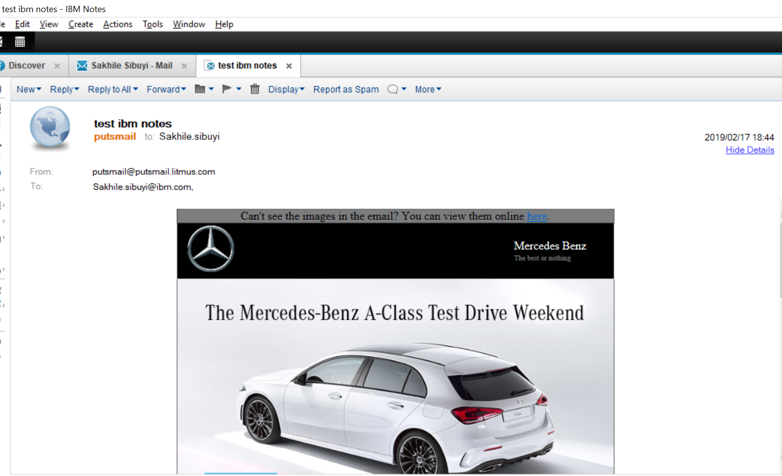

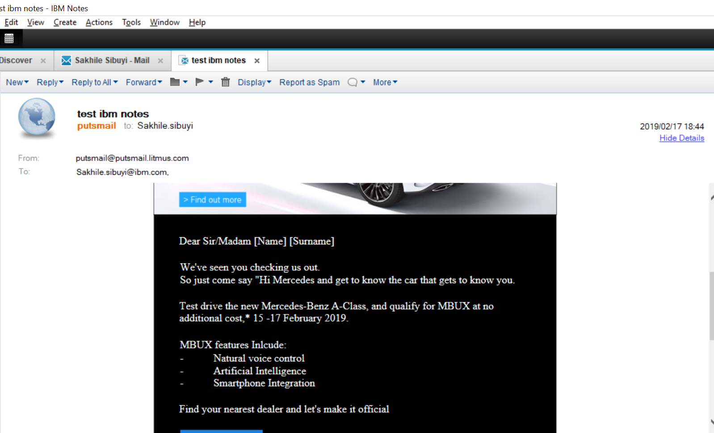

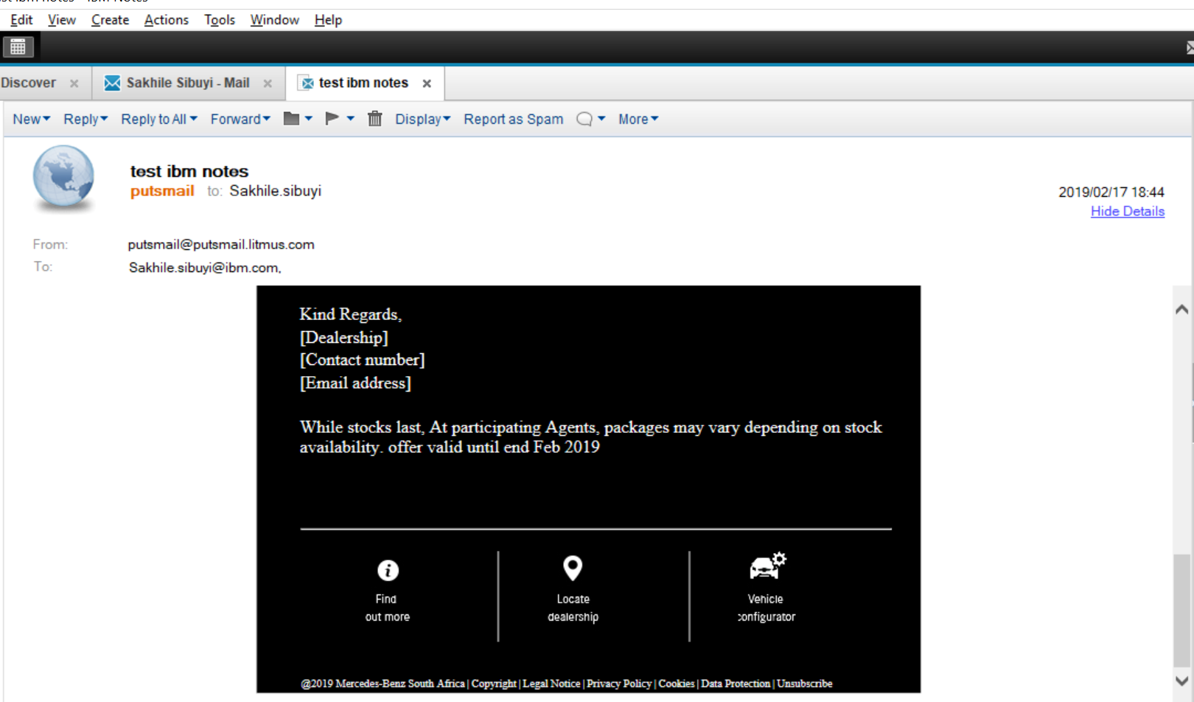

**Test result using Outlook**

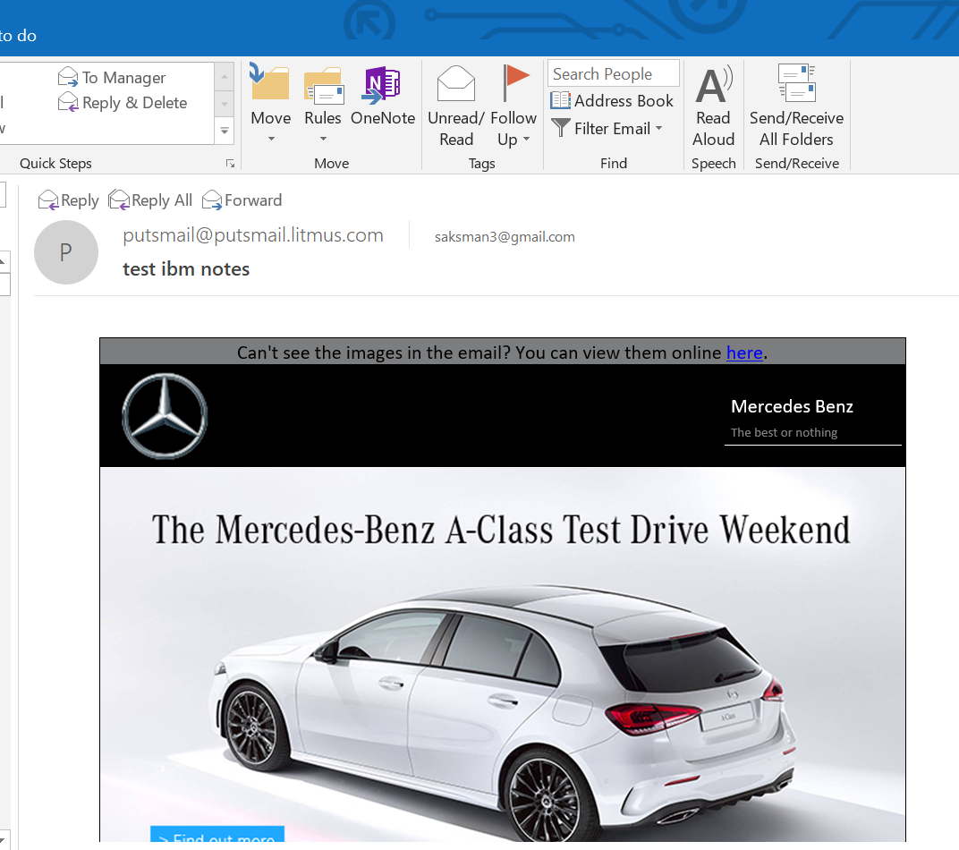

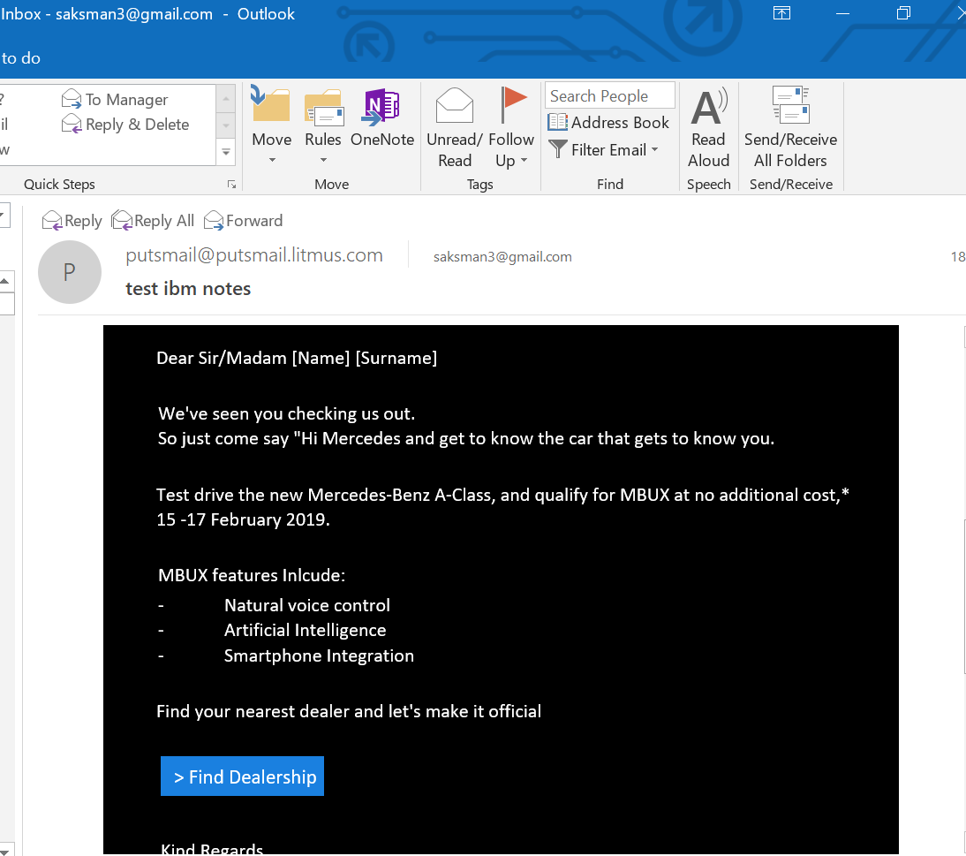

**Test Results on a Mobile device,**

